Simple E-commerce Inventory Management System (Java)

STATEMENT OF THIS TOPIC :-   
  
The Simple E-commerce Inventory Management System in Java is a program that allows you to manage an inventory of products in an e-commerce system. It provides basic functionalities such as adding products to the inventory, removing products, updating product quantities, and retrieving product information.

The program consists of two classes: `Inventory` and `InventoryManagementSystem`.

The `Inventory` class represents the inventory and uses a `HashMap` to store the products. Each product is identified by a unique product ID (integer) and has a corresponding quantity (integer). The class provides methods to add a product to the inventory, remove a product, get the quantity of a product, and update the quantity of a product.

The `InventoryManagementSystem` class serves as the entry point for the program. It creates an instance of the `Inventory` class and demonstrates the usage of its methods. Initially, some products are added to the inventory with their respective quantities. The inventory is then displayed, showing the product IDs and quantities. The program showcases updating the quantity of a product, removing a product from the inventory, and retrieving the quantity of a specific product.

The program provides a simplified implementation of an inventory management system, focusing on the core functionalities. It can serve as a starting point for more complex inventory management systems, where additional features like price tracking, product categorization, or order management can be incorporated.

FLOWCHART  
  
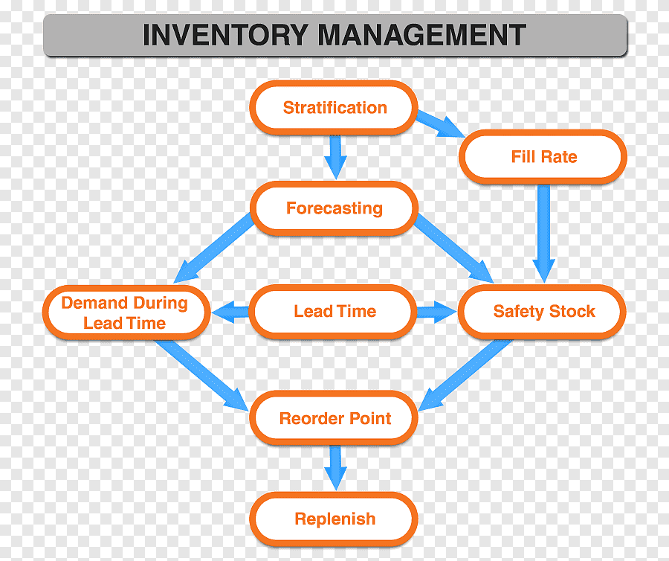  
  
  
CODE :- import java.util.HashMap;

import java.util.Map;

class Inventory {

private Map<Integer, Integer> products;

public Inventory() {

products = new HashMap<>();

}

public void addProduct(int productId, int quantity) {

products.put(productId, quantity);

}

public void removeProduct(int productId) {

products.remove(productId);

}

public int getQuantity(int productId) {

return products.getOrDefault(productId, 0);

}

public void updateQuantity(int productId, int quantity) {

products.put(productId, quantity);

}

}

public class InventoryManagementSystem {

public static void main(String[] args) {

Inventory inventory = new Inventory();

// Adding products to the inventory

inventory.addProduct(1, 5);

inventory.addProduct(2, 8);

inventory.addProduct(3, 12);

// Displaying the inventory

for (Map.Entry<Integer, Integer> entry : inventory.products.entrySet()) {

System.out.println("Product ID: " + entry.getKey() +

", Quantity: " + entry.getValue());

}

// Updating quantity of a product

inventory.updateQuantity(2, 15);

// Removing a product from the inventory

inventory.removeProduct(3);

// Displaying the updated inventory

System.out.println("Updated Inventory:");

for (Map.Entry<Integer, Integer> entry : inventory.products.entrySet()) {

System.out.println("Product ID: " + entry.getKey() +

", Quantity: " + entry.getValue());

}

// Getting the quantity of a product from the inventory

int quantity = inventory.getQuantity(1);

System.out.println("Product 1 Quantity: " + quantity);

}

}  
  
  
OUTPUT :- 